|  |
| --- |
| **CURRICULUM VITAE** |

**PERSONAL INFORMATION**

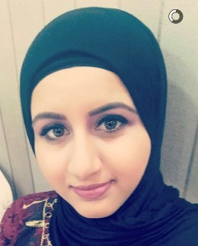**NAME** Fatema Yahya Mohammed

**DATE OF BIRTH** 11/01/1996

**MARITAL STATUS Married**

**ADDRESS** H:1502,R:4353,Bani

Jamrah 543

**MOBILE** 66641519

**EMAIL** [fatima096@outlook.com](mailto:fatima096@outlook.com)

**NATIONALITY** Bahraini

**EDUCATIONAL BACKGROUND**

2013-2017: Associate Diploma in Office Management studies from University of Bahrain, **GPA: 2.86**

2010-2013: High school certificate from Al Shurooq Secondary

School.

**KEY EXPERIENCE**

* Training at University of Bahrain in Department of Media &University Relations

**CERTIFICATES OF APPRECIATION**

1. A certificate of appreciation from INJAZ.
2. A certificate of appreciation from Citi Bank.
3. A certificate of appreciation from AIESEC.

**COMPUTER PROGRAMS**

1. Ms Office (Word, Excel, Power Point, Access, Outlook, Publisher, Adobe Dreamweaver).
2. Speed of typing Arabic and English.
3. Internet.

**OTHER SKILLS**

1. Team Worker.
2. Good Communicator.
3. Ability to work under Pressure.
4. Confidence.
5. Data Analysis.
6. Time Management.
7. Multi-tasking

**LANGUAGES**

1. Arabic.
2. English.

**AREAS OF INTEREST**

1. Internet.
2. Computer programs.
3. Learning languages.
4. Reading.

